Title - 18 point Arial font, bold, lowercase
One single free space line (12 pt)
Name SURNAME1, Name SURNAME2* and Name SURNAME1 Correspondence author must be marked by asterisk (*). Use 12 pt Arial font. Set paragraph space 6 pt before and after.
One single free space line (12 pt)
¹ Affiliation using 10 point Arial font – list all affiliations in English (each in separate line)
² Affiliation – set paragraph space 6 pt before and after, *correspondence: e-mail
Two single free space lines (12 pt)

Abstract – 14 pt Arial font, lowercase
The manuscript should be submitted in doc(x) file format. Abstract may have a maximum of 250 words. Text should be left oriented with single spacing. Use only Arial 12 point font type for all text except for manuscript title, headings, authors’ affiliations and footnotes. Abstract should be informative. It should give the context or background for the research and should state the goals, basic procedures, main findings (giving specific effect sizes and their statistical significance, if possible), and principal conclusions. It should emphasize new and important aspects of the research or observations. Abstract should not have any special headings (Goals, Results...). Abstract should be written as a continuous text that consists of one paragraph only. Do not put references in abstract. Also, non-standard or uncommon abbreviations should be avoided, but if essential, they must be defined at their first mention in the abstract itself.
One single free space line (12 pt)
Keywords – 12 pt Arial, bold: keyword 1, keyword 2, keyword 3 List up to 10 keywords in alphabetical order and separate them with comma (,). Do not use any special symbols or abbreviations as keywords.
One single free space line (12 pt)

Introduction – 14 pt Arial
Regardless to page orientation, the margin on left and right should be 2.5 cm and on top and bottom should be 3 cm (That area is used by JCEA automatic online publishing system, so anything within that area is going to be erased in manuscript publishing process). Do not put page numbers.
Manuscript text, including tables, figures and cited literature, should be contained in single file. The manuscript should be submitted in doc(x) file format. For main title use 18 pt Arial, bold. For other headings use 14 pt Arial. For subheadings and word “Keywords:” use 12 pt Arial, bold. For affiliations and footnotes use 10 pt Arial. Do not numerate headings.
The general outline is: Introduction, Materials and methods, Results, Discussion (or Results and discussion), Conclusions, Acknowledgements, References. If not needed, acknowledgements may be omitted. This scheme may not be suitable for every publication (economics, sociology). Authors should adjust their chapters according to their topic but follow the general outline as much as possible.
Use impersonal mode when writing (avoid using words like “we”, “our”, “us”).
One single free space (12 pt)

Materials and methods – 14 pt Arial
Do not put blank lines between paragraphs. Use 6 point paragraph spacing before and after for title, author names, affiliations, all headings, subheadings, keywords, footnotes, manuscript text, table and figure captions and references. Do not break (hyphenate words) on right margin.
Use symbol font for displaying Greek letters and symbols. Do not use bold or italic font face for emphasis. Use italic for words and symbols, such as scientific species names, that should appear italicized in print.
One single free space (12 pt)
Subheading – 12 pt Arial, bold
Use one single free space line before subheading and no free space between subheading and text that follows.
One single free space (12 pt)
Results – 14 pt Arial
All tables and figures should be placed in the text, where most suitable. Figures and tables, including their captions, must be easily readable and self-explanatory.
Tables should be consisted out of three thin horizontal lines that are wide as manuscript text (Table 1). Put thin border only above and below table’s header row (first row) and thin border below table’s footer row (last row). Put table caption above table with one single free space line between text and table caption, and one single free space after table (or table footnotes, if there are any). Table caption and text in tables should be centered, except for first column text which should be left aligned. Use 6 point paragraph spacing before and after table captions. Tables should not be separated in two pages. Be sure that each table (Table 1) is cited in the text.
One single free space (12 pt)
Table 1. Table caption – 12 pt Arial, centered
Sample 1a | Number | 2nd Number
Sample 1 | 100 | 0.1
Sample 2 | 300 | 0.2
Sample 3 | 500 | 0.3
a Place table footnotes below the table and mark them with superscript lowercase letters. Use 10 pt Arial for footnotes, with 6 pt paragraph space before and after.
One single free space (12 pt)
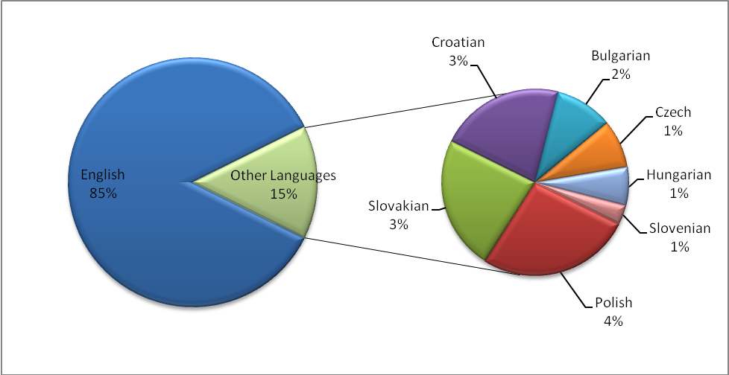
Figure footnotes
Figure 1. Figure caption – 12 pt Arial, centered
One single free space (12 pt)
Be sure that each figure (Figure 1) is cited in the text. Center align figure captions and figures on page and don’t wrap text around them. Put figure caption below figure.
For expressing the level of statistical significance use conventional abbreviations, for example, P<0.05, P<0.001 or P>0.05.
One single free space (12 pt)

Discussion – 14 pt Arial
Use impersonal mode when writing (avoid using words like “we”, “our”, “us”). Do not use bold or italic font face for emphasis. Use italic for words and symbols, such as scientific species names, that should appear italicized in print.
The main manuscript chapters may vary, depending on the type of the theme and research. The general outline is: Introduction, Materials and methods, Results, Discussion (or Results and discussion), Conclusions, Acknowledgements, References. This scheme may not be suitable for every publication (economics, sociology). Authors should adjust their chapters according to their topic but follow the general outline as much as possible.
Citation in text should be written as: if single author: Horvat (2003) or indirectly (Horvat, 2003). If two authors: Horvat and Szabo (2010) or indirectly (Horvat and Szabo, 2010). If multiple authors: Horvat et al. (2005) or indirectly (Horvat et al., 2005).
If you are quoting several works published by the same author in the same year, they should be differentiated by adding lowercase letter directly, without space, after year. For example, Horvat (2003a) or Horvat (2003b).

Conclusions – 14 pt Arial
Conclusions should not contain references.
One single free space (12 pt)
Acknowledgements – 14 pt Arial
If not needed, acknowledgements may be omitted.
One single free space (12 pt)

References – 14 pt Arial
References should be arranged first alphabetically and then further sorted chronologically if necessary. References should be written in 12 pt Arial, single space with 17.5 mm line hanging and with paragraph space set at 6 pt before and after. Include DOI number where available. DOI numbers have to be hyperlinked. Please ensure that every reference cited in the text is also present in the reference list (and vice versa).
Bahelka, I., Gondeková, M. (2016) What is the current quality of cow’s meat in Slovakia in comparison with meat of bulls? Journal of Central European Agriculture, 17 (1), 1-11. DOI: 10.5513/JCEA01/17.1.1660
Croatian Agricultural Agency (2011) Annual report for 2010, Identification and registration of domestic animals. [Online] Križevci: Croatian Agricultural Agency. Available at: http://www.hpa.hr/wp-content/uploads/2014/06/05%20Oznacavanje_2011.pdf [Accessed 4 September 2012].
Cygan-Szczegielniak, D., Stanek, M., Giernatowska, E., Janicki, B., Stasiak, K., Roślewska , A. (2015) Impact of the breeding region and the season on the content of the selected mineral elements in the hair of cows. Journal of Central European Agriculture, 16 (4), 423-435. DOI: 10.5513/JCEA01/16.4.1648
Schmidt, J. (1996a) About hives and bees. Chicago: University of Chicago Press.
Schmidt, J. (1996b) The life of a honeybee. Chicago: University of Chicago Press.
Schmidt, J., Buchmann, S. L. (2003) Other products of the hive. In: J. M. Graham, ed. (2003) The hive and the honeybee. Hamilton, IL: Dadant & Sons, 927-988.
Srečec, S., Liber, Z., Erhatić, R., Dolgoš, J., Šatović, Z. (2009) Variability of some phenotypic traits of wild hop populations in Croatia. In: Rak-Cizej, M., Čeh, B., Proceedings of 46th Hop seminar with international participation. Portorož, Slovenia, 12-13 February 2009, Žalec, Slovenia: Slovenian Institute for Hop Research and Brewing.

